Answer the following question:
- The following picture is ………………. ECG rhythm

- Regular
- Irregular

- The following picture represents …………………..
- Unipolar leads
- Bipolar leads
- Chest leads
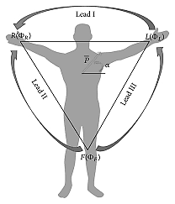

- ……………. Is placed at fifth intercostal space at mid clavicular line
- V3
- V4
- V5
- V6

- The following picture is ………………. ECG rhythm
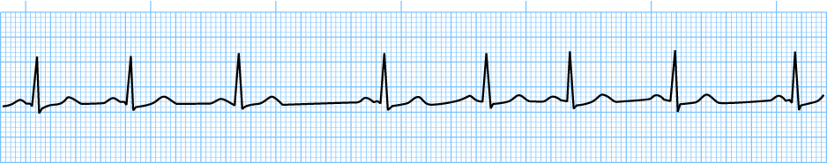
- Regular
- Irregular

- …………….. Represents depolarization of right and left atrium.
- P wave
- PR interval
- QRS wave
- ST segment

- On ECG graph paper, the horizontal axis measures……………………:
  - Time.
  - Speed.
  - Voltage.
  - Amplitude

- To gather information about impulse conduction from the atria to the ventricles, study the:
  - P wave.
  - PR interval.
  - ST segment.
  - T wave.
- Atrial and ventricular rates can be determined by counting the number of small boxes between:
  - The end of one P wave and the beginning of another.
  - The middle of two consecutive T waves.
  - Two consecutive P or R waves.
  - The beginning of the P wave to the end of the T wave
- A 72-year-old patient calls you to his room because he’s experiencing substernal chest pain that radiates to his jaw. You record a rhythm strip and monitor his vital signs. Which portion of the patient’s ECG complex may become elevated or depressed indicating myocardial damage?
  - T wave
  - ST segment
  - QRS complex
  - P wave
10 - …………………..Represents normal conduction through the AV node and the bundle of His
- P wave
- ORS wave
- PR interval

